
Tongue-Tie and Speech Articulation
Nicole Gaudiano B.S., Eastern Illinois University
Beth Bergstrom, M.S., CCC-SLP Eastern Illinois University
Ann Dralle, M.S., CCC-SLP Eastern Illinois University
Rebecca Throneburg, PhD, CCC-SLP Eastern Illinois University

Tongue-Tie

Also known as “ankyloglossia,” tongue-tie refers to the impairment of tongue mobility. Tongue-tie most commonly impacts speech and/or feeding.

•Treatment may consist of surgical intervention to release the frenulum for more mobility. Speech therapy alone cannot improve mobility

•Physical characteristics usually consist of a short frenulum which may be thick or thin. Some are unseen without a manual lift of the tongue

•Most common phonemic errors are /t,d/, /s,z/, /ð, θ/, /n/, /l/, /r/ (Messner & Lalakea, 2002)
•Incidence: worldwide 3-16% of infants (Ingram, J., Johnson, D., Copeland, M., Churchill, C., Taylor, H., & Emond, A., 2015)

Incidence reported is highly dependent on the profession reporting. Currently, there is no universally accepted criterion to diagnose tongue-tie (Suter & Bornstein, 2009)

Tongue-Tie and Speech Intelligibility

•Evaluation of Speech Intelligibility in Children with Tongue-Tie (Dollberg, Manor, Makai, & Botzer, 2011).
•Over the course of several years, the research found that children who had surgical remediation of tongue-tie in infancy were more intelligible than children who had tongue-tie but never received surgical remediation.

•The Effect of Ankyloglossia on Speech in Children (Messner & Lalakea, 2006).
•Researchers determined the difference in lingual movement and articulation pre and post surgical intervention in 30 children ages 1-12. Speech evaluation revealed that 11of the 30 children had articulation errors related to limited mobility.
•1-week, 1-month, and 3-month post-op data revealed that 9 of the 11 children demonstrated increased lingual mobility and articulation accuracy.
•The children who did not show gains included one young child who still had developing speech sounds and another child who had an ongoing articulation disorder post-surgery.

Purpose

•The purpose of this case study was to determine if there was a difference in accuracy of articulation in children diagnosed with tongue-tie and co-occurring speech disorders pre/post-surgical intervention using the Goldman Fristoe Test of Articulation, Third Edition (GFTA-3).

•Interest in this case study stems from the lack of research related to surgical intervention of tongue-tie and its potential impact on articulation.

•Effectiveness of Tongue-Tie Division for Speech Disorder in Children (Ito, Shimizu, Nakamura, & Takatama, 2015).

Reviewed the impact surgical intervention had on five children from ages three to eight years old with co-occurring tongue-tie and articulation disorder.

•Four of the children improved in articulation accuracy post-surgical intervention while one child who already developed articulatory compensation strategies did not make gains. The results were collected 1 month, 3-4 months, and 1-2 years post-op. Most articulation errors were on the phonemes /s/, /d/, /t/, and /r/.

Participants

SF, 10-year-old Caucasian male with the following: moderate articulation disorder, mild expressive language delay, and secondary encoding and decoding deficits. Received articulation therapy pre-diagnosis of ankyloglossia for 5+ years with limited progress.
Homeschooled with 4 other siblings who also have speech disorders.

Previous raw scores on GFTA-3:
Fall 2016: 44
Fall 2017: 28
Fall 2018: 26

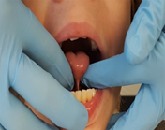

HJ, 8-year-old Caucasian female with the following: moderate articulation disorder, orofacial myofunctional deficits, oral dysphagia, and language processing deficits. Received articulation therapy pre-diagnosis of ankyloglossia for 4+ years with limited progress.
•Received Myobraces on 11-7-2018 (post-frenectomy).
•Attended 3rd grade public school, special education services in cross-categorical classroom.

Previous raw scores on GFTA-3:
Spring 2016: 54
Fall 2016: 30
Fall 2018: 15

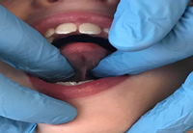

*Raw scores are total articulation errors made*

Surgical Intervention Type

SF, 10-year-old male: FRENOTOMY
A reduction, release, or partial removal of the frenulum. Frenotomy may improve the length or mobility in the tongue, but often does not provide a full release of the frenulum. Patients often require follow-up intervention for additional reductions if the tongue is not fully released or have the frenulum grow back. SF’s frenotomy was completed by a general ENT.

HJ, 8-year-old female FRENECTOMY
A complete removal of the frenulum via laser. (Baxter & Hughes, 2018). HJ’s frenectomy was completed by a board certified pediatric dentist who specialized in tongue-tie remediation.

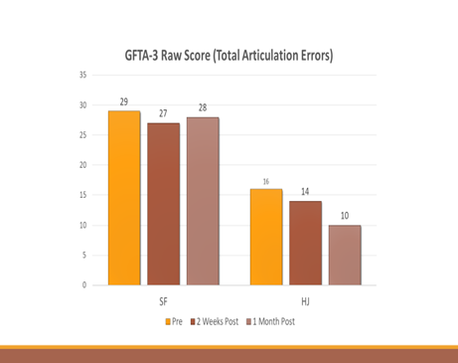

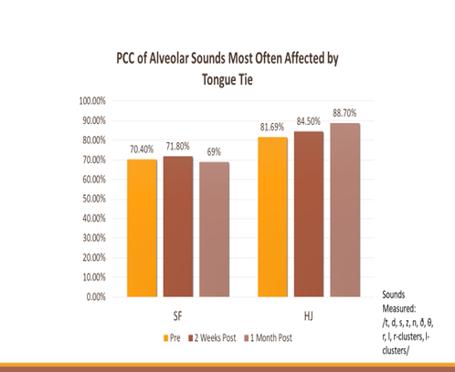

Conclusions

• SF’s (10-year-old male) post-FRENOTOMY no improvement in articulation.
- Considering his age, it is likely that SF has already developed his speech patterns and compensatory strategies; therefore, making his frenotomy not as impactful related to articulation accuracy.
- Speech therapy intervention focused on literacy and traditional articulation therapy.
- Additionally, because he was homeschooled, SF’s communication models were limited to his immediate family who all have speech impairments of their own.
- For this specific client, the frenotomy was not enough to correct the speech limitations associated with his tongue-tie as there possibly was not enough of a release to make a significant difference in his articulation ability.
- Articulation therapy alone may have been ineffective.

• HJ’s (8-year-old-female) post-FRENECTOMY articulation assessment revealed that 5 of the 10 phonemic errors associated with tongue-tie resolved themselves by 1-month post-surgical intervention.
- HJ received a complete frenectomy; therefore, a full release of her tongue may have allowed for a significant increase in its mobility and articulation accuracy.
- Therapy focused on articulation accuracy and orofacial myofunctional deficits including: swallowing, resting posture of the tongue, lingual-palatal suction, bolus transport, and overall oral dissociation tasks.

Relation to Past Research

Similarities

• Results for the participants were consistent with Ito et. al. (2015). The lack of progress in 1 of 5 of Ito’s participants and 1 of 2 of the current participants may have
due to the development of compensatory strategies.

Differences

• SF age was slightly older than those of the participants in the comparative past research. Ito’s research referenced frenuloplasty/frenectomy whereas this research refers to a frenotomy and frenectomy. In the comparison research, the length of time passed was nearly 2 years whereas this research was conducted over one semester consisting only of 3 data points.

Overall: surgical intervention may influence articulation ability, but more studies must be conducted in order to confirm this statement.

Clinical Implications & Future Research

- Findings suggest that surgical intervention may improve articulation ability for those with tongue-tie.
- The type of surgical intervention, who conducts it, and the age of the participant must be taken into consideration.
- The combination of a frenectomy by a surgeon with expertise in the diagnosis and treatment of ankyloglossia, along with therapy provided by a speech-language pathologist trained in orofacial myofunctional disorders, may be more effective than traditional interventions.

Limitations:

- Co-occurring diagnoses, knowing the full profile of the client and how the diagnosis may impact articulation ability.
- Age – consider development of articulation disorders and compensatory strategies.

More research:

- The type of speech therapy provided (orofacial myofunctional therapy vs. traditional articulation) should be further investigated in this population.
- Official diagnostic criteria for tongue-tie across professions is needed.
- Teaching speech-language pathologists to objectively assess oral structures to:
- Prevent misdiagnosis
- De-stigmatizing intraoral assessment and surgical interventions available.
- Utilize a larger population sample of those who receive intervention related to articulation and surgical intervention for tongue-tie.

References:

Baxter, R., & Hughes, L. (2018). Speech and feeding improvements in children after posterior tongue-tie release: A case series. International Journal of ClinicalPediatrics, 7(3), 29-35.

Dollberg, S. Manor, Y., Makai, R., & Botzer, E.,(2011). Evaluation of speech intelligibility in children with tongue-tie. Acta Paediatrica, 100(9), e125-e127.

Ferrés Amat, Elvira, et al. "Multidisciplinary management of ankyloglossia in childhood. Treatment of 101 cases. A protocol." Medicina Oral, Patología Oral y Cirugía Bucal 21.1 (2016):e39-e47. Web.

Ingram, J., Johnson, D., Copeland, M., Churchill, C., Taylor, H., & Emond, A. (2015). The development of a tongue assessment tool to assist with tongue-tie identification. Archives of disease in childhood Fetal and neonatal edition, 100(4), F344-F348.

Ito, Y., Shimizu, T., Nakamura, T., & Takatama, C. (2015). Effectiveness of tongue-tie division for speech disorder in children. Pediatrics International 57(2), 222-226. Web. Messner, A. H., Lalakea, M. L. (2002). The effect of ankyloglossia on speech in children. Otolaryngology Head and Neck Surgery 127(6), 539-545.

Suter, V. G., & Bornstein, M.M. (2009). Ankyloglossia: Facts and myths in diagnosis and treatment. Journal of Periodontology 80(8), 1204-1219. Web.

